WEB DEVELOPMENT (WEDE5020w)
Keanan Lionel Freeman
ST10502037

Contents
No table of contents entries found.

Organisation overview:
a. First organization will be:
Josh H_InkStudio
https://www.instagram.com/h_inkstudio?igsh=MWg4bWRscGVqdm1qaw==
b. Brief history of the organization:
Josh is an independent tattoo artist who has been in the tattooing business since April 2023, his love for drawing/art and anime inspired him to go onto a route of tattooing as he really has a passion for it while putting smiles on clients faces. He operates his studio from a small room at his house and has only gotten better as the years go by, doing from micro size tattoos to large back or sleeve pieces.
c. Vision statement:
I believe his vision is keep improving the art and style of his tattooing as he can only get better with time/experience, keeping his clients happy is huge for him as many people continue to go back to him for more tattoo designs and I can echo this as I’ve got four from his work already.
d. Target audience:
Target audience for him is mostly people who wants to express themselves, who just loves art or get a tattoo with a meaning behind it for that specific person for example.

Website goals and objectives:
I want to make bookings much easier for clients as they will be able to view availability and book appointments via an availability calendar or booking form.
A gallery of images or a page of the artist’s previous work and tattoo designs will be available to view as well on one of the website pages.
Will be providing a brief history of the artist as clients can learn about his style, experience and history in the tattoo industry.
My website will be about trust and trying my best to attract new clients (especially people that doesn’t have social media) with a visually appealing website.
To determine how well the website is doing I will be implementing to check the number of online bookings, website traffic, portfolio engagement, and new client enquiries by using Google Analytics to track the above mentioned topics.

Current Website Analysis:
None.

Proposed Website Features and Functionality:
The features I would love to implement is the:
- Homepage that will introduce the tattoo studio, showcases his awesome designs with a book now button
- Artist portfolio of previous work, tattoo styles, experience and history.
- Booking page, allows clients to choose a preferred date and time on the availability calendar and submit a booking request that the artist will have to accept.
- Contact page which includes the studio location, contact details, social media links.
- Gallery page which will showcase high-quality images of completed tattoos to help clients choose a style of their design.
- Mobile-friendly design that will ensure the website works well on phones and computers.
- Analytics that will track daily webpage traffic.
- Services page that lists the types of tattoos and services offered, with relevant pricing where applicable.
- FAQ page.

Design and User Experience:
a. For the colour scheme I’ll go with a dark grey background instead of pure black to give it that dark and edgy vibe while using off-white text which will make font easier on the eyes instead of bright white. Bold white text accents for will be used to attract the reader’s attention to important information. The font used will be Arial for the body and for headings/sub-headings will be font Bebas Neue.
b. The layout and design will have the Navigations bar with page links to Home, Portfolio, Services, Contact and Booking page, dark backgrounds will flood the page in most areas with off-white text with some bold white/deep red accents.
c. For the user experience, the navigation will be easy, simple booking process to make it straightforward with minimally required information really, mobile-friendly design, faster loading times for images to rend without sacrificing quality to name a few.
d. Please refer to Wireframes (low fidelity) folder for wireframes.

Technical Requirements:
Using HTML for building a tattoo studio website is great for a solo artist as it will keep the website simple and easy to customize where there will only be pages/features that are actually needed for the website to be functional and approachable.
The main focus will be to show the artist’s work and easier booking.

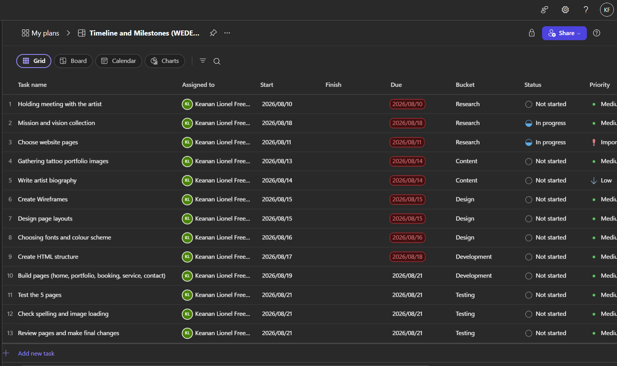
Timeline and Milestones:
Timelines

Budget:
a. Will be using Netlify to host the website as it’s free and will allow 100 GB of monthly bandwidth which will handle the high-resolution tattoo images.

Development area | Estimated cost (in ZAR)
Planning & requirements | R1 000
Website structure / wireframes | R1 000
Visual design | R2 000
HTML/CSS development | R5 000
JavaScript / interactive features | R2 000
Mobile responsiveness | R1 500
Contact/booking form | R1 000
Basic SEO | R1 000
Testing & bug fixing | R1 000
Domain + initial hosting | R0
Total | R16 500

References:
Please refer to Research folder.

2.2 Submit Two Project Proposals
This can be found in the Proposal folder.

3. Content Research and Sourcing:
This can be found in the Research folder

4. Website Structure and Planning:
4.1 Sitemap:
Home:
- Introductory statement
- Featured work
- Tattoo specialties
About:
- Short story
- Tattoo specialties
Portfolio:
- All tattoos
- Fine line
- Black and grey
- Colour
- Cover-ups
Services:
- Pricing
- Booking process
Enquiry:
- Make an enquiry
- Tattoo details
- Tattoo idea
Contact:
- Location
- Social media
- Contact details

